**3.Group member Rownita Tasneem**

Our teammate, Rownita Tasneem , has created order pages for ‘Food Delight’ and linked that pages to the ‘Add to cart’ buttons of foods. She has designed the pages in a way that these pages will take necessary user information for delivering foods to their doors. These pages will show their respective images and order related information such as quantity, name, email, and address. Customers will fill out information and after that they click the ‘Order Now’ button.

Here are the screen shots of the order pages-

1. Top part of order page

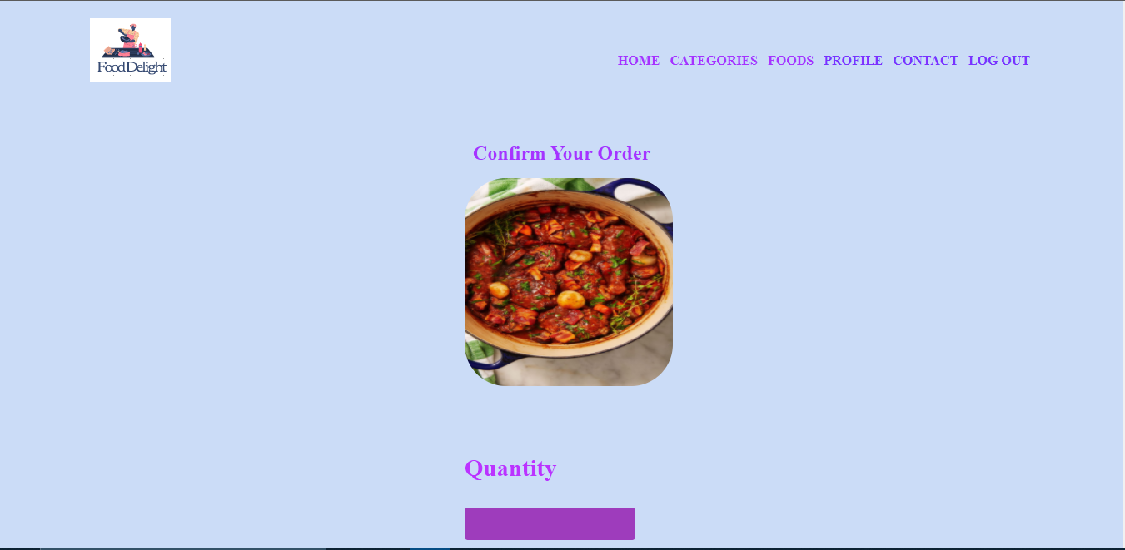

Bottom part of order page

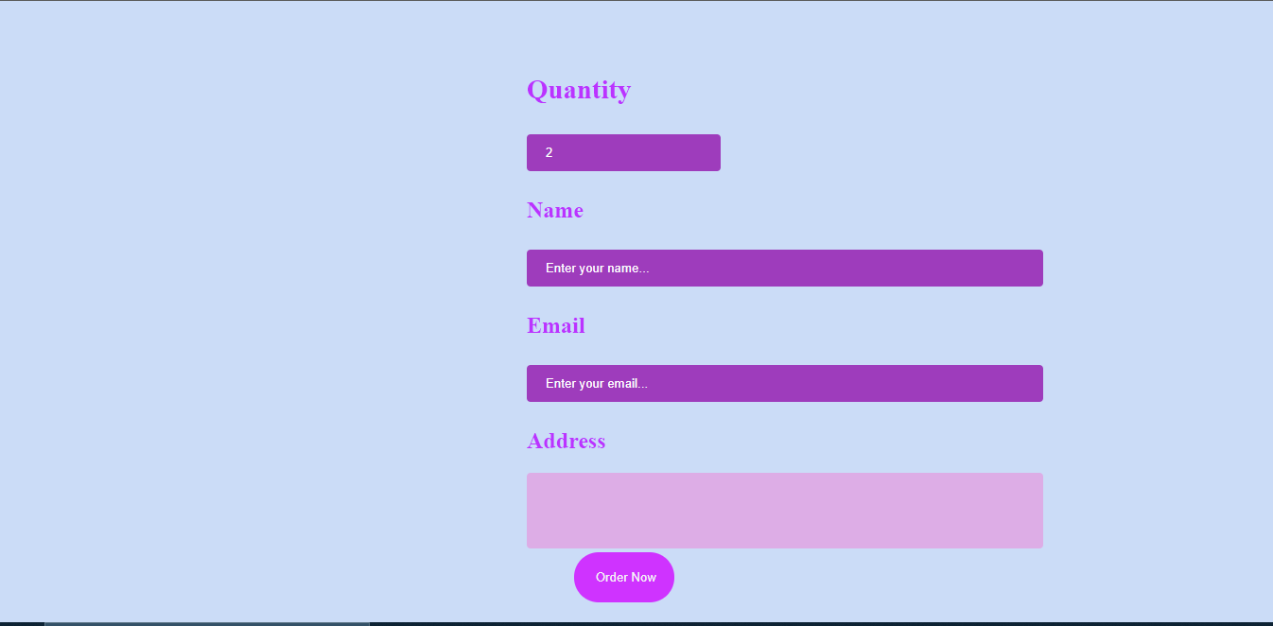

1. Top part of order page

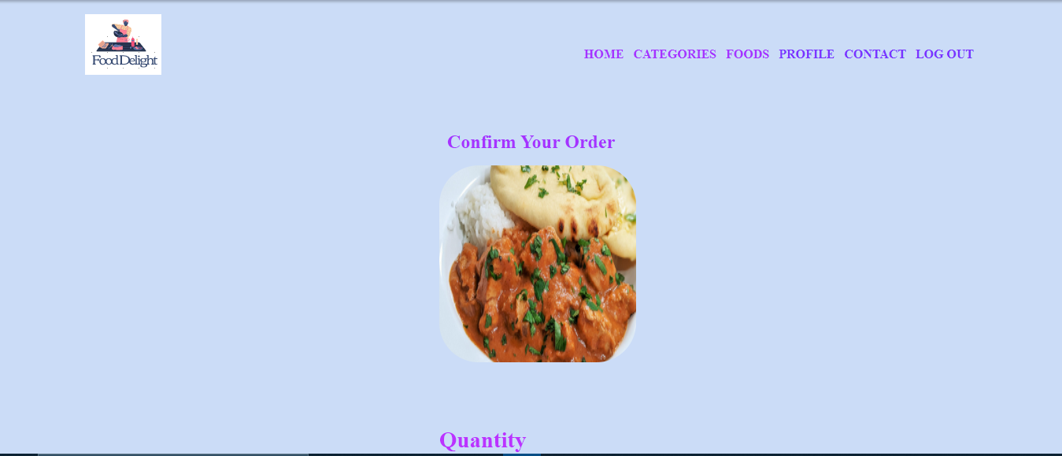

Bottom part of order page

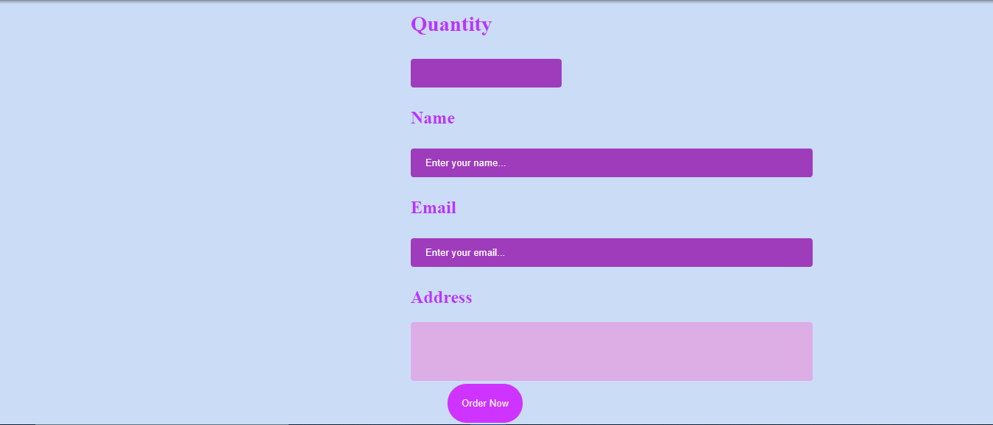

1. Top part of order page

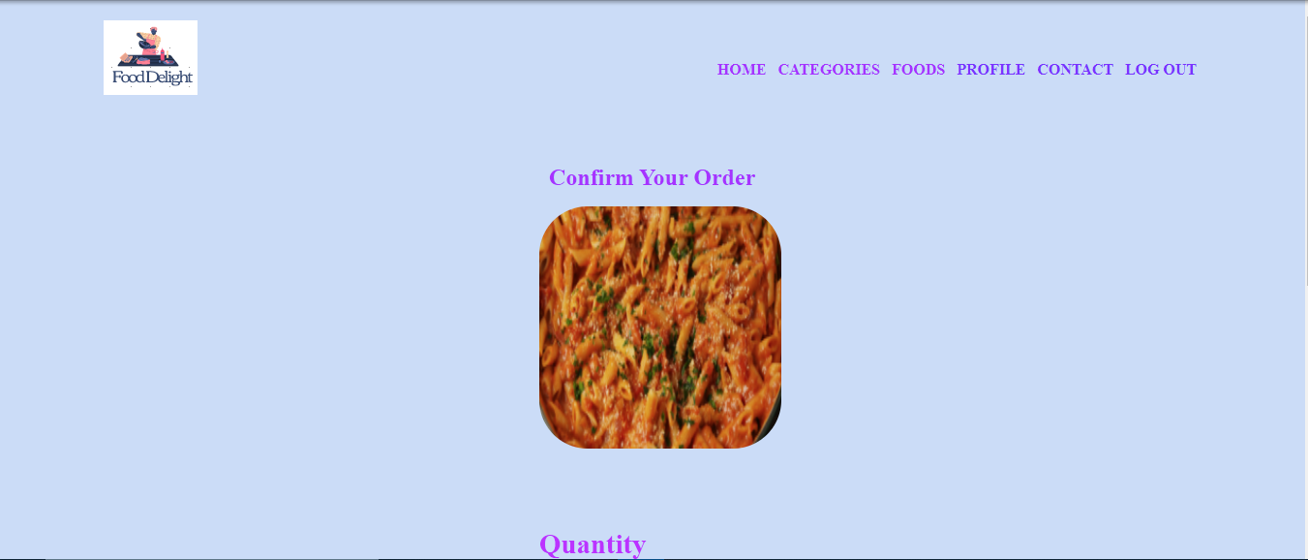

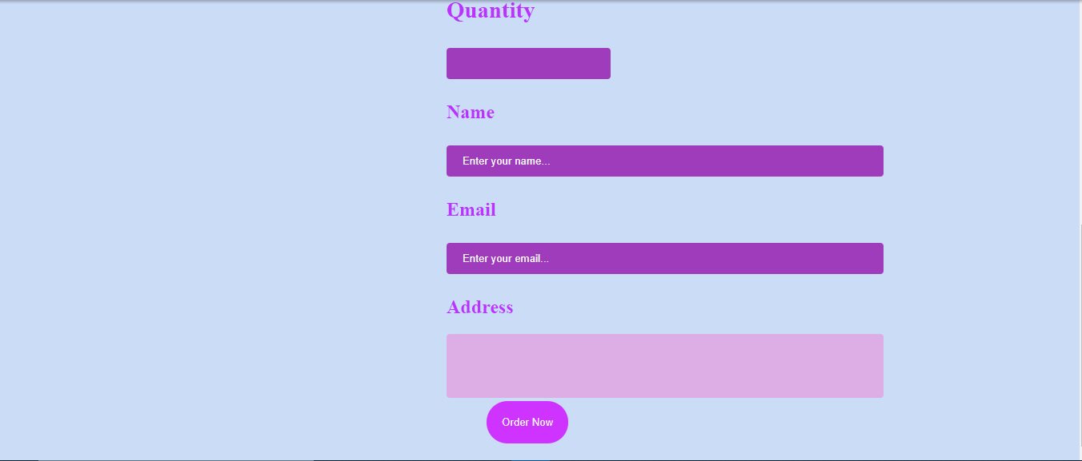

IV. Top part of order page

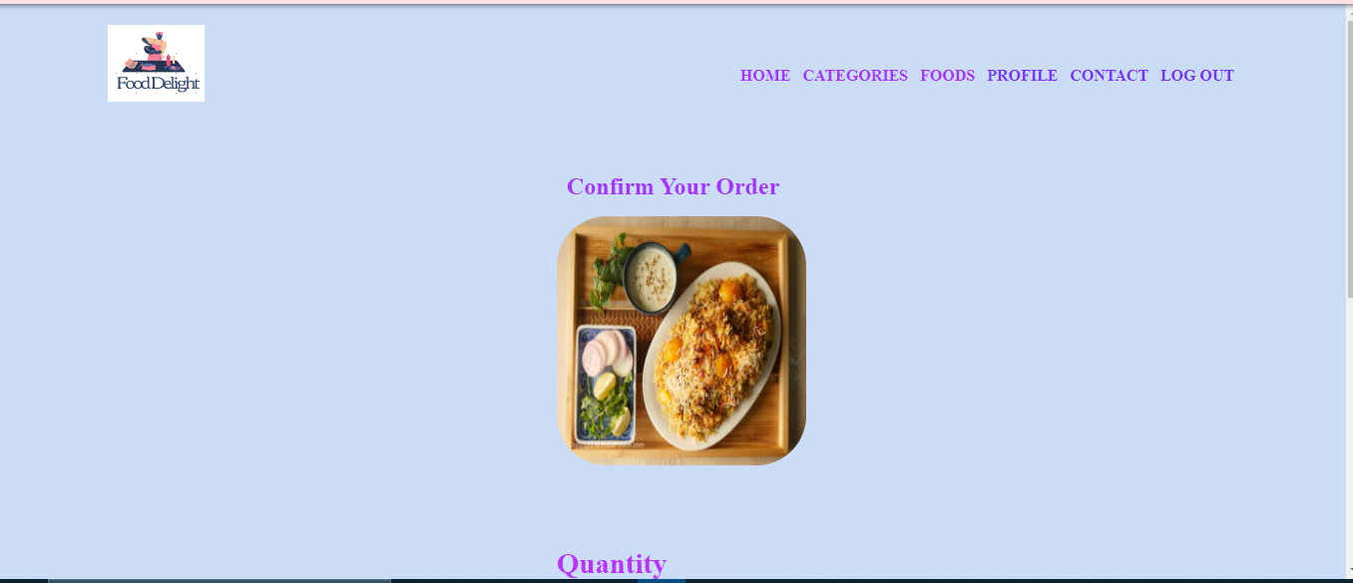

Bottom part of order page

